**Project 2: Animate a Helicopter!**

**Screenshots**

**Outside View:** 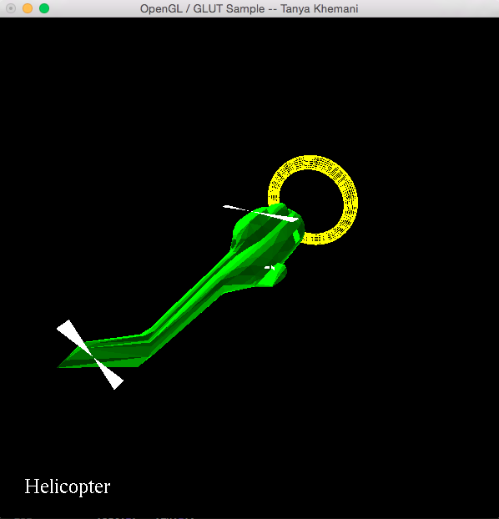

**Inside View:**

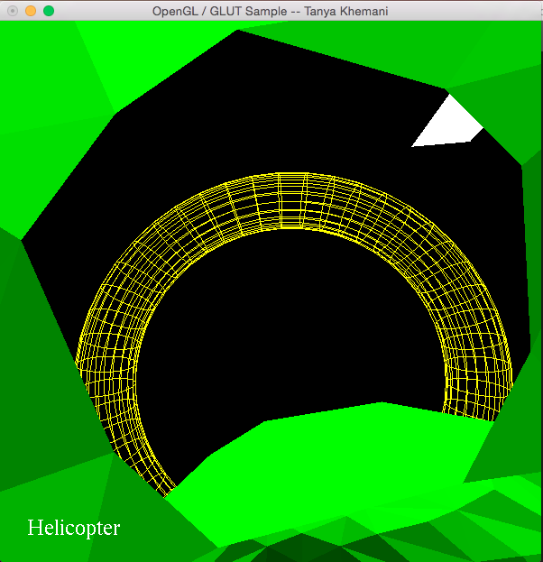

**Youtube Video Link:**

[**https://youtu.be/Ow7ralVb_9A**](https://youtu.be/Ow7ralVb_9A)